Thomas Courtney

3175353  UON

PHYS2170: Measurement of Bandgap in Germanium

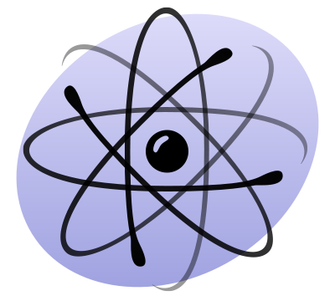

Contents

Abstract 2

Introduction 2

Procedure 4

Results 5

Discussion 8

Inaccuracy 8

Data Analysis 8

Conclusion 9

Appendix 10

Calculations 10

Bibliography 11

# Abstract

This report details the effects of temperature on the conductivity of a germanium crystal. The conductivity is calculated by using data obtained via the four-probe method. It was found that an increase in temperature increased the conductivity of the material. This is as the thermal agitation of the electrons in the valence band forced them across the band gap of the material and into the conduction band, thus engaging the *intrinsic* conductivity of the germanium. This data was used to calculate the energy band gap for germanium. The measured value for the bandgap was 0.5160eVand the calculated value for the band gap 0.4429 eV.

# Introduction

The conductive properties of semiconducting materials are dependent on the band structure of the energy levels of their electrons. The band structure is modelled as consisting of a conduction band and a valence band (See figure 1).

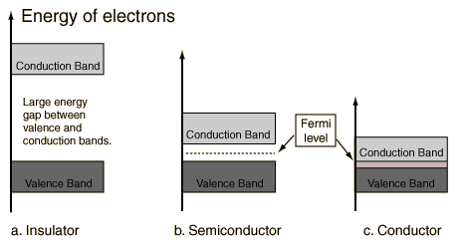

Figure : Model of the band structure of an insulator, semiconductor and conductor.

The size of the energy band gap determines the amount of energy required to move an electron from the valence band to the conduction band. The highest energy level in the valence band is called the “Fermi level”. By reducing the gap between the Fermi level and the next allowable energy level a material’s conductive properties will improve.

Another method of improving a semiconductor’s conductive properties is called “doping”. This is where molecular impurities are created by bonding group 3 or group 5 elements with group 4 (metalloids) for example silicon phosphate or germanium phosphate. The impurity introduces additional charge carrying conductors, either electrons (n-type) or electron holes (p-type) (see Figure 2). This type of conduction is termed *extrinsic* as it does not depend on the base element but the introduced impurity.

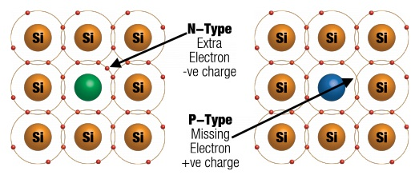

Figure : Different types of charged carries created by impurities in a silicon crystal.

Further by agitating electrons in the valence band of a semiconductor they will be sufficiently energised to jump across the band gap and into the conduction band. This creates additional electrons n-type charge carries in the conduction band and p-type charge carries in the valence band. This will promote conduction in the material and is termed *intrinsic* conduction. At absolute zero (0 °K) all electrons will be in the valence band of a material.

Germanium is a metalloid or semimetal, meaning it exhibits properties like that of a metal, most notably its conductive properties. It also has a diamond cubic crystal structure (see Figure 3.)

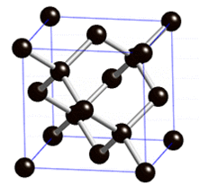

Figure 3: Fundamental unit of a diamond cubic crystal structure lattice.

By applying the four-probe method to a germanium wafer as it is heated or cooled and using that data to calculate the conductivity of the material the intrinsic and extrinsic contributions to conduction may be identified. This is as change in temperature will change intrinsic conduction but not extrinsic.

# Procedure

Using the four-probe method on a 6x8x0.05cm wafer of germanium allowed the change in resistance of the material be calculated as it cooled. The wafer was heated in a small oven and temperature was measured with a probe thermometer (see Figure 4).

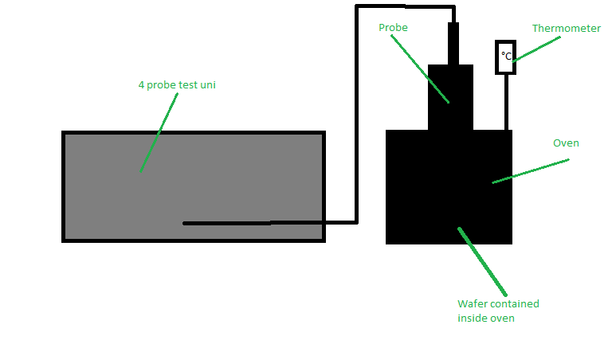

Figure 4: Apparatus for four-probe testing of germanium wafer including test unit, oven and thermometer.

The germanium wafer was heated to 170 °C and then allowed to cool. Voltage readings were taken every 5 °C until the wafer reached 50 °C and then voltage readings were taken every 2 °C until the wafer reached 34 °C.

Using the voltage/temperature data pairs at each point the resistance of the wafer could be calculated and hence the conductivity of the material (See Appendix – Calculations). Applying the natural logarithm to the calculated resistance values and plotting them against the inverse of the matching temperature value gives a near linear plot. Fitting the data to a linear plot and taking the plots gradient gives the energy gap of the germanium wafer (See Figure 5).

# Results

Figure 5: Natural log of resistance of a cooling germanium wafer plotted against the inverse of its temperature.

Table : The gradient and energy gap determined using the experimental and data for a germanium wafer. Based on Figure 5. For energy gap calculation see Appendix -Calculation **1**.

|  |  |  |
| --- | --- | --- |
| **Data Source** | **Gradient** | **Energy Gap (eV)** |
| Experimental | 2998.8 | 0.5160 |
| Calculated | 2570.9 | 0.4429 |

# Discussion

## Inaccuracy

This experiment was conducted affected by several inaccuracies. The instruments used all had associated inaccuracies, for example the thermometer±1 °C. The four-probe method assumes a number of parameters are correctly setup such as alignment of the probes and perfect contact of the probes. These things are easily executed imperfectly due to human error additionally the instrument has an associated inaccuracy of ±0.1% and ±0.1mV for the voltmeter and ±0.25% and ±0.1mA for the current generator.

In the calculation phase as the results did not produce an exactly linear plot (see Figure 5) the data was linearly fitted. The approximation affected the basis of the calculation to obtain the energy gap of the germanium sample (see Appendix- Calculations 1). Unsurprisingly the results obtained, 0.5160 eV for experimental data and 0.4429 eV for calculated data, were some 20 – 40% different to the actual value for the band gap of germanium which is 0.66 eV [1]. Due to imperfect data however, this compromise is necessary.

There was a single outlier in the measured data (see Figure 5) which can attributed to a displacement of the instrumentation causing imperfect contact with he sample or simply a random event in the hardware.

The four-probe method, though imperfect, is still superior to other method of measuring the resistivity of a material. Because the millivoltmeter is applied in parallel with the sample (see Figure 6) and it has a high impedance (10MΩ) it does not draw any current out of the circuit and affect the calculation of the resistance of the material. This calculation is based on Ohm’s law.

$$R=\frac{V}{I}$$

If the method of soldering wires onto the sample, the associated resistivity of the soldering and wires would contribute to the series resistance calculated by the probe that is mean to represent that of the sample. This in turn would generate inaccurate data, more so than data generated by the four-probe method. Comparatively the series resistance contributed by the four-probe method is very small.

The experimental data’s qualities could be improved by an increased number of trials and greater care to implement the four-probe method’s setup.

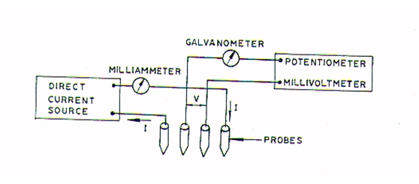

Figure 6: Four-probe method’s individual contacts diagram.

## Data Analysis

The near-linear sections of the plot in Figure 5 which are positively sloped indicate that as the sample cooled the resistance of the sample rose. This implies that the materials conductivity increased with temperature.

$$σ=\frac{1}{ρ}$$

$$Where ρ=resistvity and σ=conductivity.$$

The reason that the germanium’s conductivity rose as the sample was heated is that the thermal energy is transferred to the electrons and agitates them. If the agitation is sufficiently large the electrons may be pushed across the band gap and into the conduction band. This generates a hole in the valence band (p-type) which is a positive charge carrier. It also creates an extra electron in the conduction band (n-type) which is a negative charge carrier. This is called *intrinsic* conduction.

Figure 7: Ideal plot of change in conductivity due to temperature

In Figure 7 above, which is an ideally linear shaped dummy plot, the flat areas of the plot indicate regions of *extrinsic* conductivity, as temperature has no affect on this region. Therefore, for sufficiently small temperatures insufficient energy is supplied to electrons to cross the band gap. This is the conductive behaviour of the material without extra energy and it can be improved via doping.

# Conclusion

By using the relatively accurate four-probe method to measure the resistivity of a germanium wafer and observing the wafer’s changing resistivity as a function of temperature the band gap of germanium could be found. The measure value was 0.516 eV and the calculated value was 0.4429 eV. Disparity between the calculation and the measured value is likely due inaccuracies in measurements also the nature of the linear fit method used in excel. Likewise, this is the justification for the difference in found values and the actual value for germanium’s band gap of 0.66 eV [1].

# Appendix

## Calculations

1. *Calculation of the bandgap from the gradient of the linear fit plot Figure 5. ln(ⲣ) vs 1/T .*

$$\ln\left(ⲣ\right)=\frac{E_{g}}{2kT}-\ln\left(k\right)$$

$$\&$$

$$y ={mx+b}$$

*Therefore,*

$$m=\frac{E_{g}}{2k}$$

*Hence, $E_{g}=2km$*

# Bibliography

|  |  |
| --- | --- |
| [1] | M. Design, “Energy band structure of germanium,” materials design, 2018. [Online]. Available: http://www.materialsdesign.com/appnote/energy-band-structure-germanium. |